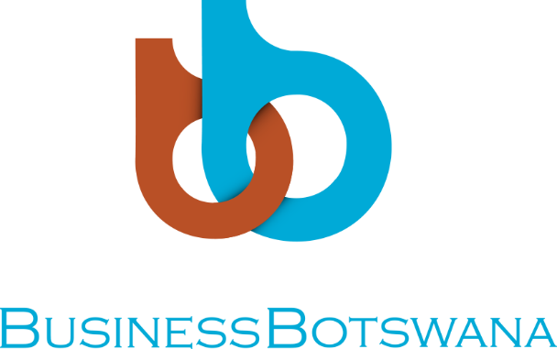

PRIVATE SECTOR CODE OF CONDUCT CONSULTATIVE MEETING

VENUE: DCEC OFFICES, FRANCISTOWN
DATE: Monday, 8th October 2018

OPENING REMARKS BY: Business Botswana Vice President North, Mr Humprey Nawa

Director of Ceremonies,
- UNDP Facilitators: Mr. Phil Matsheza and Mr. Anga Timlisna
- DCEC Senior Assistant Director Regions
- Business Botswana Regional Manager, Ms Eileen van der Est
- Captains of Industry
- Members of the Media,
Ladies and Gentlemen,

Good Morning to you all,
- It gives me great pleasure to welcome you all this morning to the private sector code of conduct consultative meeting. This meeting is part of series of other engagement with stakeholders’ country wide. I have no doubt in my mind, that this meeting will be a worthwhile experience. We have, an opportunity before us to share our experiences and suggestions so that we collectively have a better understanding of issues in corporate governance and ethics.

- Ladies and Gentlemen. As you know, good governance instills investor confidence and instigates rapid growth in markets. For Botswana to attract Foreign Direct Investment, we need to practice good governance.

- Director of Ceremonies, distinguished guests, Corruption in the private sector interferes with market mechanisms and results in economic loss through inefficiency and misallocation of resources. As businesses we must to adhere to good governance practices and standards to gain the competitive edge required to survive in competitive and dynamic markets. Good governance standards are essential to ensure transparency of capital markets, as well as to attract and retain foreign investments.

- The conversation began years ago, and on the 30th August 2001 a workshop was convened by the Directorate on Corruption and Economic Crime (DCEC), and Business Botswana (Formerly BOCCIM) and the Commonwealth Business Council (CBC) as part of a programme by CBC to encourage greater cooperation between the Government and the Private Sector in fighting corruption. In preparation for the workshop a number of interviews were conducted to highlight how corruption affects business activity and the investment climate and to review the legal constitutional and administrative arrangements currently in place to counter the threat of corruption. The workshop participants (representatives from all sectors) felt that while Botswana rightly enjoys a good reputation for the integrity of the business environment, corruption and mal-administration remain significant problems within the Government and private sector. Concerns were also raised regarding issues of conflict of interest, which arise as a result of links between the public servants, private companies and politicians.

- Following the workshop an Agenda for Change was endorsed and agreed upon. Recommendations in the Agenda included the development of comprehensive guidelines on corporate governance, which could be encompassed in a Code of Conduct for the Private Sector, recommendation on how Government might simplify and rationalise public administration in order to eliminate the scope of corruption.

Following the thorough stakeholder engagement, the Code of Conduct for the Private Sector was launched in 2011. The purpose of the code is to guide the private sector against unethical behaviour when conducting their business activities. At the launch, about 15 companies signed the code, subsequent, a further 60 companies signed. However, the implementation of the code was unsatisfactory as BB members and all businesses were not adhering to set guidelines. Since the signing was on voluntary basis, members always about “what’s in it for them?”

- Ladies and gentlemen, Business Botswana and DCEC with the assistance of UNDP saw it fit to review the code of conduct and to ensure that it is aligned with international standards and brings in an element of an incentive. There is also a need to recognize those who have signed and adhere to the code.
- Ladies and gentlemen, the mandate of the consultant is simple, from this forum; they will design a code of conduct that is within international standards and propose for incentives so to attract more adherence and uptake from businesses. With this approach, we believe more businesses will uptake the signing of the code. We therefore urge PPADB to come on board and incentivize the code.

- Ladies and Gentleman. I believe it is the joint responsibility of all economic participants, and not just the regulators, to promote and enforce good governance practices. To reap the maximum benefits of governance systems, it should be in practice embraced by all, as an avenue for value creation and sustainability. I call upon all entities from Government to Civil societies to play an active role in promoting ethical corporate governance and ultimately urging businesses to sign the code once ready.

- I am confident that, with commitment from all of us here, we will attain our goal for excellence in corporate governance and business ethics.

- I would like to sincerely thank our experts for their commitment and assures them that this meeting will be as engaging and fruitful as the meeting in Gaborone.

- Ladies and gentlemen, let me once again than you for attending this session and appeal to all of you to be participative and engage with the consultant.

