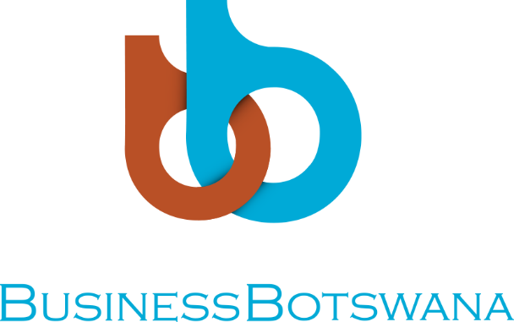

BUSINESS BOTSWANA NORTHERN TRADE FAIR

VENUE: TATI RIVER LODGE
DATE: Saturday, 26th May 2018

OPENING REMARKS BY: Business Botswana President, Mr Gobusamang Keebine

Director of Ceremonies,
- Guest of Honour – Okavango Diamond Company, Mr Marcus ter Haar,
- Mayor of Francistown, Her Worship Ms Sylvia Muzila
- Kenya High Commissioner- Her Excellency, Ms Jean W. Kimani
- First Secretary Consular Affairs in the Namibian High Commission, Mr Jordan Hashoongo
- Former President of Business Botswana, Mr Iqbal Ibrahim
- Member of Parliament- Francistown East, Honourable Mr buti Billy
- Member of Parliament- Francistown South, Honourable Mr Winter Mmolotsi
- District Commissioner, Ms. Chabongwa Matsika
- Honourable Councillors here present,
- Members of the diplomatic corps,
- Acting BB Chief Executive Officer, Mr Norman Moleele
- Captains of Industry
- Members of the Media,
Ladies and Gentlemen,

Good Morning to you all,

- It gives me great pleasure to welcome you to the 24th Business Botswana Northern Trade Fair. Director of Ceremonies, I suffice to mention that though this is my first Trade fair as the President of Business Botswana, the fair has been in existence from humble beginnings in 1994 and it has grown to become a national networking platform.

- When I attained the Presidency of Business Botswana last year, my aim was to improve the stakeholder engagement of Business Botswana as well as boost its membership. Although, there is progress, I believe we can achieve more if we cooperate and collaborate on issues of doing business. I would like to see our members and local authorities engaging in meaningful and fruitful dialogue for the betterment of local economies.

- Ladies and gentlemen, this fair brings the business community together create business linkages, networking and partnerships including the establishment of key business relations. Many businesses from micro, medium to large have benefited from this initiative, and many businesses here today, if not, all started out by merely trading at a stall at this trade fair and today they are proud contributors to Botswana’s economy.

- Ladies and gentlemen, it is worth emphasising that the number of exhibitors continues to grow every year. Not only do exhibitors showcase their products and services but they also get a chance to implement new approaches for market promotion. The BB Northern Trade Fair is a great platform to have face-to-face communications for both exhibitors and potential clients and act as a powerful impetus of growth of businesses.

- Distinguished guests, Ladies and gentlemen, for us in Botswana, the private sector’s role has not only been operational in terms of constructive dialogue / engagement, we have been engaged by government in key developmental strategies and policy formation. The private sector through Business Botswana has been instrumental in improving our doing business environment. With Botswana’s economic landscape changing, and being focused more towards diversification, it has become even more imperative for private sector to take the lead.

Master of Ceremonies, as at 2017, Botswana’s rating by both Standard & Poor’s and Moody’s Investors rating agencies is “A grade,” which can be beneficial in attracting the much needed Foreign Direct Investment (FDi). I believe the City of Francistown can use this ratings as a way to market Francistown as the City to do business in.

- Distinguished guests, it gives me great honour to state that as the private sector, we compliment efforts by Government in order to ensure the realization of the country’s national Vision 2036. It is with that background that I implore each and every business, to constantly look at how best it can improve its performance for the benefit of this nation.

- Ladies and gentlemen, the theme for this year’s theme is “Is Tourism, Botswana’s hope amidst dwindling mining fortunes?” Francistown is still reeling from the effects of the closure of Tati Nickle Mine, the time is now to make Francistown the best city to do Business in. And this can be achieved through our collective efforts in profiling Francistown as the Investment destination of choice!!! Food for thought, in collaboration with the City of Francistown, “What can we do to help improve efficiency in Francistown, produce quality goods and services and attract investors into the City?”

- I would like therefore to extend my gratitude to Mr Marcus ter Haar for honouring our request and unpack today’s theme.

- Distinguished guests, trade opportunities are fundamental in transforming our economic diversity and growth, for long-term sustainability, positive social impact and poverty alleviation. In 2016, we signed a Memorandum of Agreement with the Kenya National Chamber of Commerce (KNICC) purposely to strengthen trade relations ties and to tap into both the Kenya and Botswana markets. Kenya is amongst the top 10 largest economies in Africa and it is a great opportunity for exhibitors even the City of Francistown to forge strategic partnerships to tap into the Eastern African Market through Kenya. We will be signing more MoUs with our counterparts in other countries. Such agreements are meant to facilitate business- to-business (B2B) relations and it requires us to seize opportunities arising thereof.

- Master of Ceremonies, Ladies and gentlemen, Botswana has signed trade agreements with her global counterparts such as the African Growth and Opportunity Act (AGOA), EU- Economic Partnership Agreement (EPA), Tripartite Free Trade Agreement (TFTA). As a small market, businesses from Botswana should take advantage of the opportunities provided by these agreements. As an example, Lesotho’s economy soared by 3% in 2017 following the extension of AGOA in 2015.

- It is worth noting that neither government nor the private sector alone can be the sole actor in ensuring Botswana’s macroeconomic growth. An innovative entrepreneurship driven economy can result in a vibrant export led market, collectively, both parties must collaborate to ensure that the business environment thrives.
- To all businesses exhibiting here today, this is your time. Seek opportunity for growth for your own business, but keep in mind how you can collectively contribute to the growth of Botswana’s economy.

- Ladies and gentlemen, I welcome you all to the 24th Business Botswana Northern Trade Fair.

Thank you!

