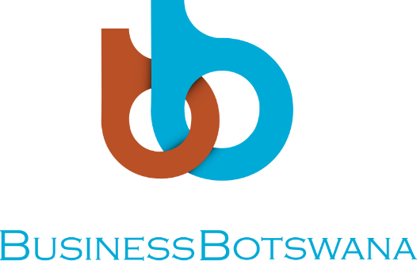

WELCOME REMARKS

DATE: Saturday, 12th May 2018
VENUE: Cresta Lodge
TIME: 1400hrs – 1430hrs

REMARKS BY:
DIRECTOR-BUSINESS DEVELOPMENT SERVICES, Ms. Zoe A Isaacs

Director of Ceremonies,
Guest of Honour- Mrs Batsho Dambe-Groth
Presenters: Ms. Neo Tlhaselo, Ms. Ntombi Setswaelo and Mr. Thabo Mhlanga
Media here present
Distinguished guests,

Ladies,
I greet you all and welcome you to this occasion. I must say, you all look beautiful and dressed to the theme!

Ladies and gentlemen, it is with great pleasure to welcome you to the 5th Women’s Power High Tea event. It is always admirable and amazing how small things can turn into big things. This high tea started very small, now 5 years later, it has grown to something else, now an event not to be missed!

But this morning is not all about business, it’s about empowerment! As women, we tend to naturally be competitive, and multi-tasking, but this comes with a lot of strain. So we need to be balanced. As women, we have the courage and wisdom to stand up for what we believe in, so that we may deal with any situation that comes our way.

Over the years, we have had brilliant guest speakers and presenters, many who forced us to think outside the box, and others who made us assess our own efforts as decision makers. All of them have left memorable impressions in our minds. However, I personally, am particularly excited to have a powerful Motswana Woman as a guest speaker, she is phenomenal and has a vast wealth of experience in Business. Mrs. Batsho Dambe-Groth will share her experiences and dissect today’s theme “Be Empowered. Be a Raregem.”
She is accompanied by three (3) seasoned entrepreneurs and motivational speakers who will be emphasising women’s role in increasing and diversifying the economy of Botswana, highlighting the challenges faced by women in business and how to overcome these challenges and most importantly motivate entrepreneurial and aspiring women to develop their career and expand their knowledge. For the first time, we have a male speaker amongst us, who is going to give us a perspective of what men think of us women in business.

Ladies and well gentleman, this is not a formal official event, it’s a get together. Even if you walk out of here today having learnt one thing, then that’s all that matters. But please take this opportunity to pass out business cards, network and let’s drive entrepreneurship amongst us women. We are powerful and can achieve many things simultaneously, so let’s start now.

Not to prolong the speech, when we started this event in 2012, a proportion of the proceeds were donated to Cancer Association Botswana (CAB). We saw it befitting to partner with CAB yet again to assist them with the sensitization campaign. Globally, Cancer is a silent killer and Botswana is not immune and we are truly humbled by your presence, as it has contributed to the fight against cancer. Part of the proceeds will be donated to CAB in a few weeks’ time.

Okay enough talk! Today is about celebrating Women…Networking, mingling and interacting with progressive women. We have a wine and cheese tasting just by the foyer and I do believe we will have a good opportunity to enjoy the rich taste of wines distributed by Fine Brands Limited. Please also visit a few stalls of women owned businesses showcasing their fantastic products and service.

Ladies enjoy the session and please take this opportunity and get network and mingle!
Thank you!

